

**Batch: B-3 Roll No.: 16010422234 Experiment No.: 3**

**______________________________________________________________________________**

**Aim:** To write problem definition, persona and use case

**______________________________________________________________________________**

**Resources needed:** Web Resources

**Theory:**

Identifying personas and use cases is an important step in user interface design.

**Personas**

Personas are complementary to a scenario-based approach to requirements engineering. Specific names of the personas are used in the description of the scenario. Personas are defined by their needs and goals. These include their personal goals as well as their goals for the system. A goal-directed design project may, and probably will, have multiple personas because different kinds of users with different goals will use the system. The system may not be designed for all personas. However, each system will have at least one primary persona.

A primary persona is someone who must be satisfied with the system for it to be considered a success and who cannot be satisfied with an interaction designed for another persona. The user interaction designed for each primary persona should be based on the needs and goals of that persona.

Example of persona:

Following is example of persona for online song streaming application:

“Being a student, Chirag travels 2 hours daily, and his long commutes are usually very boring. Therefore, he looks for some form of entertainment like movies, songs and TV series. There’s a plethora of new content to consume and it’s not possible to download all the material out there, therefore using an online portal is the best way for Chirag. He is also interested in dance and music and therefore is always in search of new and different music. He owns a laptop and a cell phone. While travelling he uses his cellphone and can use the mobile app to listen to songs. He uses his laptop for gaming and for his college studies. Thus, he can use the website too.”

**Use case:**

Use cases are a mechanism to help keep it simple and understandable for all stakeholders. Informally, they are stories of using a system to meet goals. Use cases often need to be more elaborate than this, but the essence is discovering and recording functional requirements by writing stories of using a system to help fulfill various stakeholder goals. A scenario is a specific sequence of actions and interactions between actors and the system under discussion; it is also called a use case instance. It is one particular story of using a system, or one path through the use case; for example, the scenario of successfully purchasing items with cash, or the scenario of failing to purchase items because of a credit card transaction denial.

Informally then, a use case is a collection of related success and failure scenarios that describe actors using a system to support a goal.

Use cases are requirements; primarily they are functional requirements that indicate what the system will do. Use cases are text documents, not diagrams, and use case modeling is primarily an act of writing, not drawing. However, the UML defines a use case diagram to illustrate the names of use cases and actors, and their relationships.

**______________________________________________________________________________**

**Procedure:**

Write problem definition, personas (minimum two), use cases (minimum five)

Topic - "Language Learn"

A language-learning app that uses gamification to make learning fun and engaging.

Features: Gamified lessons, daily streaks, points, badges, and leaderboards.

**Result:**

**Problem Definition:**

The increasing global interest in language learning is driven by the need for communication in a globalized world. However, traditional language-learning methods can often be tedious and lack engagement, leading to decreased motivation and high dropout rates. The aim is to develop a language-learning app called "Language Learn" that leverages gamification to make the learning process more fun and engaging. The app will feature gamified lessons, daily streaks, points, badges, and leaderboards to motivate users to continue learning and improve their language skills consistently.

**Personas**

Persona 1: Maria, the Busy Professional

* Background: Maria is a 28-year-old marketing executive who recently relocated to Germany for work. She needs to learn German quickly to communicate effectively with her colleagues and clients.
* Goals:
  + To learn basic conversational German within three months.
  + To practice German daily, even with her busy schedule.
* Challenges:
  + Limited time due to a busy work schedule.
  + Needs to stay motivated and consistent in her learning.
* Motivations:
  + Improve her career prospects by mastering German.
  + Earn badges and maintain streaks as a way to track progress.
* Technology Use: Uses her smartphone extensively for work and personal tasks.

Persona 2: Alex, the High School Student

* Background: Alex is a 16-year-old high school student in the United States who is passionate about learning new languages. He is currently taking Spanish classes in school.
* Goals:
  + To improve his Spanish vocabulary and grammar skills.
  + To engage in language learning in a fun and interactive way outside of the classroom.
* Challenges:
  + Finds traditional learning methods boring and prefers interactive activities.
  + Needs consistent practice but lacks motivation when using non-gamified tools.
* Motivations:
  + Compete with friends on the leaderboard.
  + Earn points and badges as a measure of progress and accomplishment.
* Technology Use: Enjoys using his smartphone and tablet for gaming and educational apps.

**Use Cases**

Use Case 1: Start a New Lesson

* Actors: Maria, Alex
* Description: The user selects a new language lesson from the app's curriculum. The lesson consists of a series of interactive exercises and quizzes. The user earns points based on their performance in each exercise.

Use Case 2: Maintain a Daily Streak

* Actors: Maria
* Description: The user is reminded daily to complete at least one lesson or practice session. Successfully completing a lesson each day contributes to maintaining a daily streak, which boosts motivation and rewards the user with bonus points.

Use Case 3: Compete on the Leaderboard

* Actors: Alex
* Description: The user can see how they rank against other users on a global leaderboard. Points earned from completing lessons and challenges contribute to the user’s ranking. Users are motivated to perform better to climb up the leaderboard.

Use Case 4: Earn Badges for Achievements

* Actors: Alex
* Description: The user earns badges for achieving specific milestones, such as completing a set number of lessons, maintaining a streak for a certain number of days, or mastering a level. These badges are displayed in the user’s profile.

Use Case 5: Review Past Lessons

* Actors: Maria
* Description: The user can review past lessons and exercises at any time to reinforce learning. The app provides quick access to previously completed lessons and quizzes, allowing the user to refresh their memory.

<https://www.figma.com/design/d4uVmx2CIheQjUcMBpKvgl/Language-Learn?node-id=0-1&t=8gLfUcCEtplXyyG1-1>

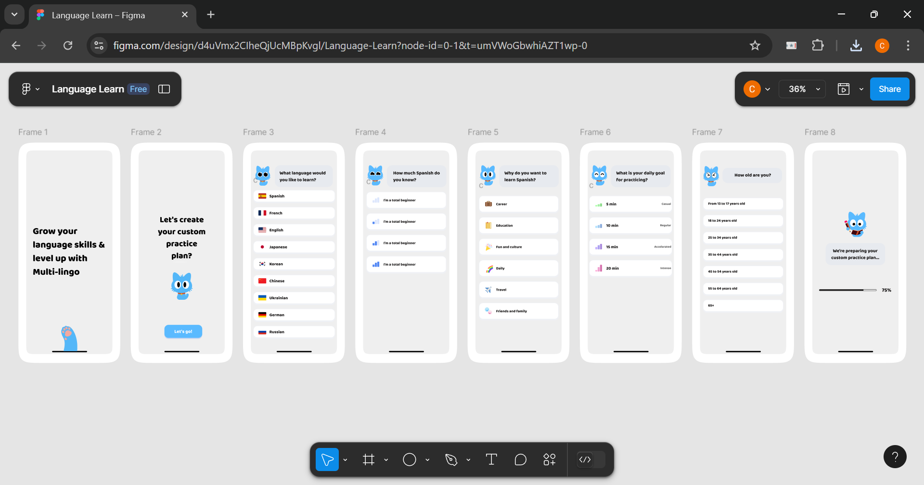

**______________________________________________________________________________**

**Outcomes: Comprehend role of user and designer in User Interface Design**

**______________________________________________________________________________**

**Conclusion: (Conclusion to be based on the objectives and outcomes achieved)**

The "Language Learn" app design process began with a clear understanding of the problem it aims to solve: making language learning more engaging through gamification. By developing detailed personas and use cases, we ensured that the app would meet the needs and goals of its target users. The proposed features, such as gamified lessons, daily streaks, points, badges, and leaderboards, are aligned with the motivations of the users, ensuring that they remain engaged and motivated to learn. The outcomes achieved in this experiment provide a solid foundation for further development and eventual implementation of the app in Figma.

**______________________________________________________________________________**

**Grade: AA / AB / BB / BC / CC / CD /DD**

**Signature of faculty in-charge with date**

**______________________________________________________________________________**

**References:**

1. Wilbert O. Galitz, “The Essential Guide to User Interface Design - An Introduction to GUI Design Principles and Techniques”, Wiley Computer Publishing, Second Edition, 2002
2. Bill Scott, Theresa Neil, “Designing Web Interfaces Principles & Patterns for Rich Interaction”, O’rielly Media, First Edition, 2009
3. Randolph, Gary. "Use-cases and personas: a case study in light-weight user interaction design for small development projects." Informing Science: International Journal of an Emerging Transdiscipline 7 (2004): 105-116.
4. Stein, Ben. "6 Use-Case Model: Writing Requirements In Context."

**______________________________________________________________________________**